***Curriculum Vitae***

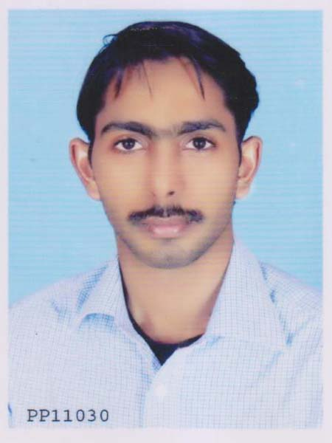

***M.Salman Arif***

**E-mail-** [**Salman_arifpk@hotmail.com**](mailto:Salman_arifpk@hotmail.com)**, Cell No - +92.333.7673229.**

**OBJECTIVE:**

Looking for a responsible and challenging position with a growth oriented Organization with a professional environment.

Management Skills:

1. Excellent organization and time-management skills.
2. Ability to handle projects to achieve expected results.
3. Dedicated and committed, willing to take on challenging roles, tough assignments and work to tight schedules.

**Skills:**

* Personnel Management, Motivation, Relationship Management, Training, Organizational Dynamics.
* Communication, Leadership, Interpersonal, Analytical, Problem Solving & Decision Making Skills
* IT Skills: MS Office Applications, QuickBooks, Peachtree, Tally, Windows XP & 7, Web Browsing & Research.

**Experience:**

**2010 – 2012:  Computer operator, A.N.Traders Responsibilities:**

* **Recording computer information such as occurring problems, operating time and actions taken**
* **Performing scheduled and regular maintenance checks on computer terminals and desktop PCs**
* **Loading peripheral equipment’s in use with selected materials for operation and overseeing computer-related operations**
* **Determining the tools and equipment required to undertake a particular job and making necessary requisitions**
* **Clearing office equipment’s at end of operations and reviewing upcoming schedules to facilitate smooth operations in the next session.**
* **Continuously monitoring the IT systems for equipment malfunction, failure or errors in performance**
* **Typing commands and transferring encoded data into the computer storage**
* **Entering commands into a computer terminal and activating controls on computers and peripheral equipment’s to operate the equipment.**

**Career Level:**

Career Level: Entry Level

Notice period to work: Immediate

**Education:**

**Matric(Arts).**  Duration 2004-2006.

Govt.High School Alipur (Muzaffarghar) D.G.Khan Board (Punjab) Pakistan.

**D.Com(Diploma in Commerce).** Duration 2006-2008.

Govt.Commerce College Alipur (Muzaffarghar) Punjab Board of Technical Education Lahore. (Punjab)Pakistan.

**B.A (Arts).** Duration 2010-2012.

[*Bahauddin Zakariya University*, Multan, Pakistan.](http://www.google.com.pk/url?sa=t&rct=j&q=bzu&source=web&cd=1&cad=rja&ved=0CBwQFjAA&url=http%3A%2F%2Fwww.bzu.edu.pk%2F&ei=YSs5UM7tKITYrQfluIGIBg&usg=AFQjCNEBchPctBn5ABenoDio5mxhNBC3Kg)

**OTHER SKILL:**

WEB DESIGNING & DEVELOPMENT COURSE. Duration May -12 to Aug-12.

Institute of Professional Advancement (IPA Karachi.)

**Language:** command over English and Urdu.

**Reference :** May be provided on request.

**PERSONAL INFORMATION:**

Father’s Name: Muhammad Kamran Arif Date of Birth: 19-06-1987

CNIC #: 32301-7005355-7

Nationality Pakistani Marital Status: Single Domicile: Muzaffar Ghar (Punjab. PAKISTAN.) Postal Address: 15/4 firdous colony, Golimar chorangi .nazimabad, Karachi.